
Information Systems & Software Engineering Department

Capstone Project Phase A – 61998
Deepfake Detectors - Zero Shot & Few shot

26-1-R-8

Students:
Chen Tzafir 319005104
Nir Haim Glick 207851155

Supervisors:
Dr. Renata Avros
Prof. Zeev (Vladimir) Volkovich

Git Repository: https://github.com/chentsafir/Deepfake-Detectors---Phase-A

Abstract 3
- Introduction 4
  - Key Concepts & Definitions 5
    - Encoder – Decoder Architecture 5
    - Generative Adversarial network (GANs) 5
- Theoretical Background 6
  - The Landscape of Deepfakes: Generation & Detection 6
  - Deepfake Generation Methods-SimSwap 6
  - Traditional Detection and Self-Blended Images (SBI) 8
  - SBI Algorithm Operational Flow 11
  - InstructBLIP 11
  - Zero-Shot Learning (ZSL) 13
  - Few-Shot Learning (FSL) 14
- Methodology 15
  - System Overview 15
  - Probabilistic Inference Algorithm 16
  - Training And Fine-Tuning Strategy 16
  - System Inputs 17
    - Visual Datasets 17
    - Textual datasets 18
    - Model Evaluation and Result validation 18
    - Test Plan 19
- References 20

Abstract

This study investigates the efficacy of Visual Language Models (VLMs), specifically the InstructBLIP architecture, as robust zero-shot deepfake detectors capable of overcoming the generalization limitations of traditional binary classifiers. While state-of-the-art generative methods like SimSwap produces high-fidelity forgeries with minimal visual artifacts, traditional detection methods such as Self-Blended Images (SBI) often struggle with generalization to unseen attacks. The research gap arises because most existing detectors focus on low-level visual artifacts and blending boundaries. In contrast, VLMs use broad semantic understanding acquired from massive pre-training. This results in higher robustness against out of distribution samples.
This project proposes and validates an approach that transforms the binary classification task into a visual question answering problem using the generative text output of VLMs. The method uses InstructBLIP with a parameter-Efficient fine tuning (PEFT) strategy that involves freezing the vision encoder and the Large Language Model (LLM) while training only the Q-Former component. This architecture allows the model to learn Deepfake-specific anomalies without suffering from catastrophic forgetting.
The methodological core is the development of a probabilistic inference algorithm. Instead of relying on raw textual output, the system extracts the logits corresponding to decision tokens and applies a normalization process to generate a continuous anomaly score. This approach significantly enhances the model’s precision.
The system’s performance is evaluated under Zero-shot and Few-shot (1-10 ratio) scenarios, utilizing challenging datasets generated by SimSwap. Validation is conducted using standard metrics (AUC) as well as Clustering analysis to measure Cohesion and Separation within the embedding space, aiming to demonstrate a clear linear separation between real and fake content.

- Introduction

In recent years, Deepfake technology went through an accelerated process of democratization, making it accessible to the public, evolving from a technological curiosity into a true everyday threat. Previously, producing high-quality forgeries required expensive hardware and extensive technical knowledge. However, today, thanks to the availability of free computing resources such as Google Colab and accessible tools like SimSwap and ComfyUI, anyone with a computer or a smartphone can create high quality, realistic fake content. This phenomenon poses a significant challenge to Know Your Customer (KYC) systems, biometric verification mechanisms, and media platforms. According to recent reports, Deepfake-based identity fraud has quadrupled in just one year.
Most existing detection methods, such as FaceForensics++ or frequency-based models like M2TR, operate as "Pixel Detectives": they focus on identifying specific visual artifacts or hidden noise at the pixel level. advances models such as SBI (Self-Blended Images) achieve impressive performance by generating synthetic training samples that mimic forgery artifacts, these approaches suffer from a lack of Generalization. The models tend to overfit to the forgery methods that they were trained on, and they are proven to be fragile when exposed to simple alterations such as image compression and noise. The central limitation is the model’s inability to comprehend the whole semantic value of a photo, limiting its ability to cope with unseen threats (Zero-Shot Scenarios).
To bridge this gap, this project proposes an innovative approach based on VLMs (Visual Language Models), specifically leveraging the InstructBLIP architecture. These models combine a frozen Image Encoder with a frozen LLM (Large Language Model), connected via a dedicated component (Q-Former) that enables the model to "understand" natural language instructions. The central hypothesis is that the Zero-Shot capabilities and deep semantic understanding of these models, acquired from pre-training on vast datasets, will allow for more robust detection of anomalies and forgeries compared to models that were trained solely for a specific task.
A key challenge in using VLMs for security systems is that they are generative models producing text (e.g., a binary "Yes" or "No" answer), which does not provide the confidence score that is required for thresholding and calculating metrics like AUC. The algorithm proposed in this project transforms the generative model into a probabilistic classifier: we analyze the token distribution predicted by the model and calculate a normalized probability for the “Real” and “Fake” classes. Using normalization instead of the standard Softmax function allows us to obtain a probability vector that faithfully represents the model’s confidence score, without the distortions often created in language models.
The goal of this project is to demonstrate how using VLMs as Zero-Shot detectors outperforms traditional methods in unseen environments (Cross-Dataset), utilizing a new and challenging dataset based on CelebA-HQ. Additionally, we will examine the model’s rapid adaptability through short Few-Shot training (Fine tuning only the Q-former component), showing how this process achieves near-perfect SOTA (state-of-the-art) results on known datasets like DFDC-P, maintaining computational efficiency.

- Key Concepts & Definitions
In this section, we define the fundamental concepts and core architecture that form the foundation of this research. Understanding these concepts is essential for comprehending the methodology proposed in the following chapter, specifically how the instructBLIP model is applied to deepfake tasks.

  - Encoder – decoder architecture:
Encoder-Decoder architecture is a common framework in deep learning, made up of two main parts that process information in sequence. The encoder takes the raw input (such as an image) and compresses it into mathematical representation that contains the most essential information. The decoder uses this representation to generate the final output (such as text or reconstructed image).
In this project, the Image encoder processes the visual information, while the language model acts as the decoder to generate the text response.

  - Generative Adversarial network (GANs)
GANs model are the basis for modern face-swapping and deepfake generation. The system uses two neural networks that compete against each other in process called ‘Adversarial training’. In this process, the Generator tries to create fake images that look as realistic as possible. The Discriminator tries to figure out if the image is real or fake.
To ensure the results look real, the training uses specific loss functions like adversarial Loss and gradient penalty. Also, in advanced system, the Discriminator does more than just classify. It compares features within its deep layers (weak feature matching), which helps the generator preserve visual details more accurately.

- Theoretical Background
This chapter establishes the theoretical foundations required to understand the proposed solution. It reviews the evolution of Deepfake generation and detection, introduces the paradigm of Vision-Language Models (VLMs), details the specific architecture of InstructBLIP, and defines the mathematical concepts used for probabilistic classification in generative models.

- The Landscape of Deepfakes: Generation & Detection
The arms race between Deepfake generation and detection has evolved significantly. While generation methods have made more accessible and high-fidelity, detection methods have struggled to maintain robustness across different domains.

- Deepfake Generation Methods – SimSwap
Modern face-swapping relies heavily on Generative Adversarial Networks (GANs) and recent diffusion-based techniques. A prominent example used in modern datasets is SimSwap.
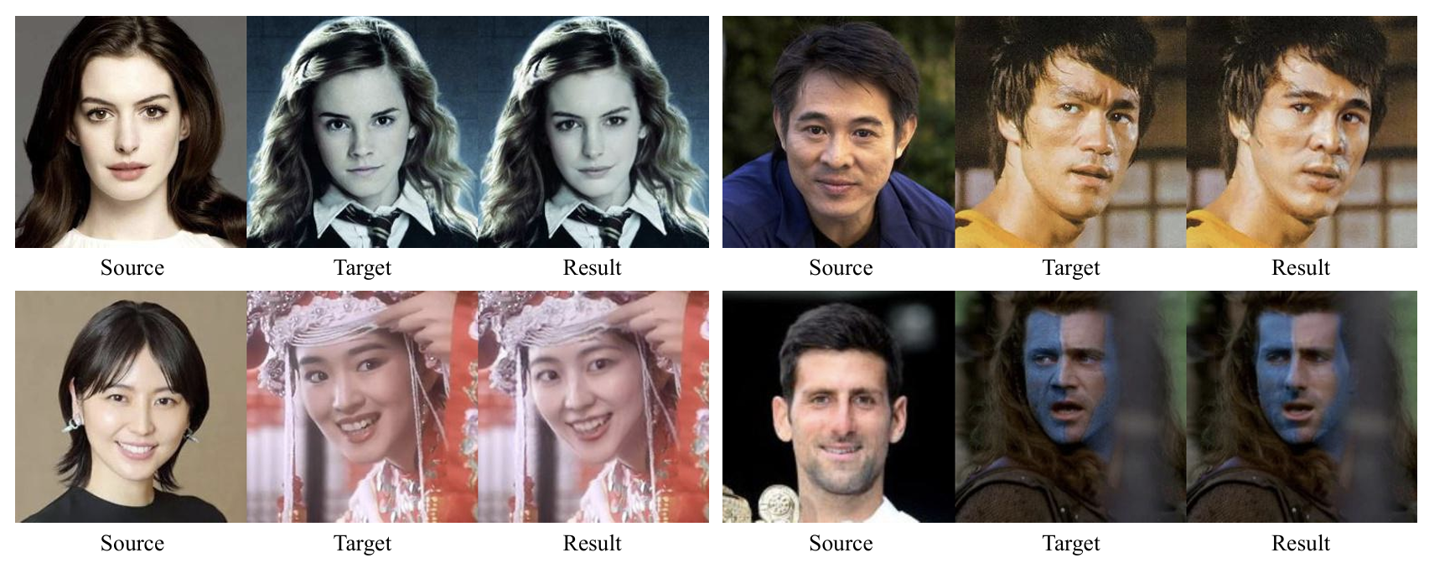
Figure 1: High-fidelity face swapping results demonstrating identity transfer while preserving attributes. Source: Chen et al., "SimSwap: An Efficient Framework for High Fidelity Face Swapping" (2020)

Face swapping results generated by SimSwap. The face is replaced in the target image with the face in the source image. More results can be found in supplementary material.
SimSwap is a state-of-the-art (SOTA) framework designed for high-fidelity, generalized one-shot face swapping. The primary objective is to transfer the identity of a source face $(I_{S})$ onto a target face $(I_{T})$ while maintaining the targets’ specific attributes, including expression, pose, lighting, and gaze direction.

To overcome the limitations of identity-specific models that require separate decoders, SimSwap introduces the Identity Injection Module (IIM). Positioned between the encoder and decoder, the IIM facilitates generalization by replacing target identity features with source identity information. The process begins with Identity Extraction, where a face recognition network (e.g., ArcFace) extracts an identity vector $v_{S}$ from $I_{S}$. This vector is then integrated via nine ID-Blocks using Adaptive Instance Normalization (AdaIN), formulated as:
$AdaIN\left(F_{ea} , v_{S}\right)=σ_{S}\frac{F_{ea}-μ(F_{ea})}{σ(F_{ea})}+μ_{S}$.
where $μ(F_{ea})$ and $σ(F_{ea})$ represent the channel-wise mean and standard deviation of the input features, while $σ_{S}$ and $μ_{S}$ are parameters derived from $v_{S}$ through fully connected layers. This architecture ensures the decoder remains independent.
To ensure that identity modification does not compromise target attributes, SimSwap employs a Weak Feature Matching Loss $(L_{wFM})$. Unlike traditional feature matching, $L_{wFM}$ operates implicitly by aligning the result ${(I}_{S})$ with the target ${(I}_{T})$ at a high semantic level, utilizing only the deep layers of the discriminator $(D)$:

$L_{wFM}(D)=\sum_{i=m}^{M}{\frac{1}{N_{i}}\left\|D^{\left(i\right)}\left(I_{R}\right)- D^{\left(i\right)}\left(I_{T}\right)\right\|}$.
Here, $M$ denotes the total number of layers, $m$ is the starting deep layer for calculation, and $N_{i}$ is the number of elements in the $i$-th layer.
The model is optimized using a multi-component loss function:
- Identity Loss ${(L}_{Id})$: Constrains the identity of $I_{R}$ to match $I_{S}$ using cosine similarity:
$L_{Id}=\frac{{v_{R}∙v}_{S}}{\left\|v_{R}\right\| \left\|v_{S}\right\|}$ .

- Reconstruction Loss ${(L}_{Recon})$: Applied when source and target identities are identical:
$L_{Id}=\left\|I_{R}-I_{T}\right\|$ .
- Adversarial Training: Employs Adversarial Loss ${(L}_{Adv})$ and Gradient Penalty $(L_{GP}$) to ensure visual realism.

The total loss is defined as:
$L=λ_{Id}∙L_{Id} + λ_{Recon} ∙ L_{Recon}+L_{Adv}+λ_{GP}∙L_{GP}+λ_{FM}∙L_{w{FM}_{sum}}$.
where $L_{w{FM}_{sum}}$ aggregates the weak feature matching loss across multi-scale discriminators.
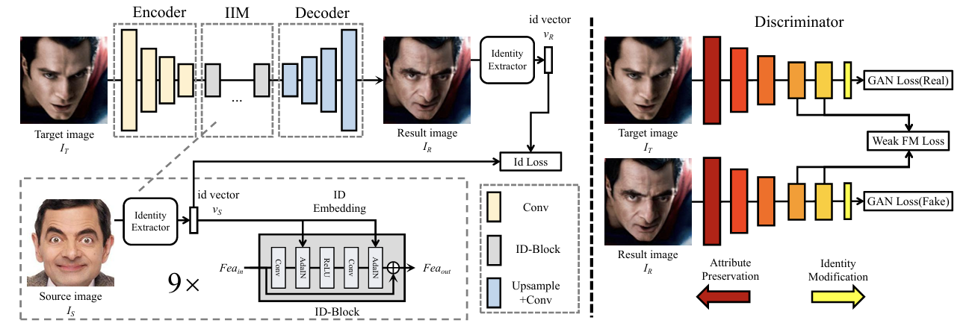
Figure 2: High-fidelity face swapping results demonstrating identity transfer while preserving attributes. Source: Chen et al., "SimSwap: An Efficient Framework for High Fidelity Face Swapping" (2020)

The framework of SimSwap. The generator consists of three parts, including the Encoder part, the ID Injection Module (IIM) and the Decoder part. Encoder extracts feature $F_{{ea}_{T}}$ from the target image IT. The ID Injection Module transfers the identity information from $I_{S}$ into $F_{{ea}_{T}}$. The Decoder restores the modified features to the result image. The Identity Loss is used to encourage the network to generate results with similar identity as the source face. We apply Weak Feature Matching Loss to make sure that the network can preserve the attributes of the target face while not harming the identity modification performance too much.

- Traditional Detection and Self-Blended Images (SBI)
Traditional detectors often rely on standard CNN backbones (e.g., Xception, EfficientNet) trained as binary classifiers. These are often termed "Pixel Detectives" because they look for low-level frequency artifacts or blending boundaries.
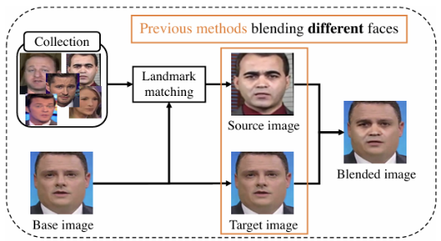
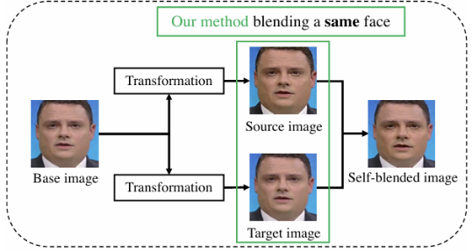
Currently, one of the most robust training methods is Self-Blended Images (SBI).
Figure 3: The Self-Blended Images (SBI) generation pipeline, creating synthetic training samples from a single source image. Source: Shiohara & Yamasaki, "Detecting Deepfakes with Self-Blended Images" (2022).

Overview of fake sample synthesis. Previous methods blend two distinct faces and generate artifacts based on a gap between selected source and target images. By contrast, the SBI method blends slightly changed faces from a single image and generate artifacts actively by transformations. In this example, the method applies the color jitter, sharpening, resizing, and performing translation are applied to the source image and no transformations to the target image.

Self-Blended Images (SBIs) are a novel synthetic data generation technique designed to enhance the generalization of Deepfake detectors, particularly in cross-dataset scenarios. Conventional detectors often overfit specific manipulation artifacts: SBI addresses this by generating "harder" fake samples that encourage models to learn more robust, generic representations of forgery.

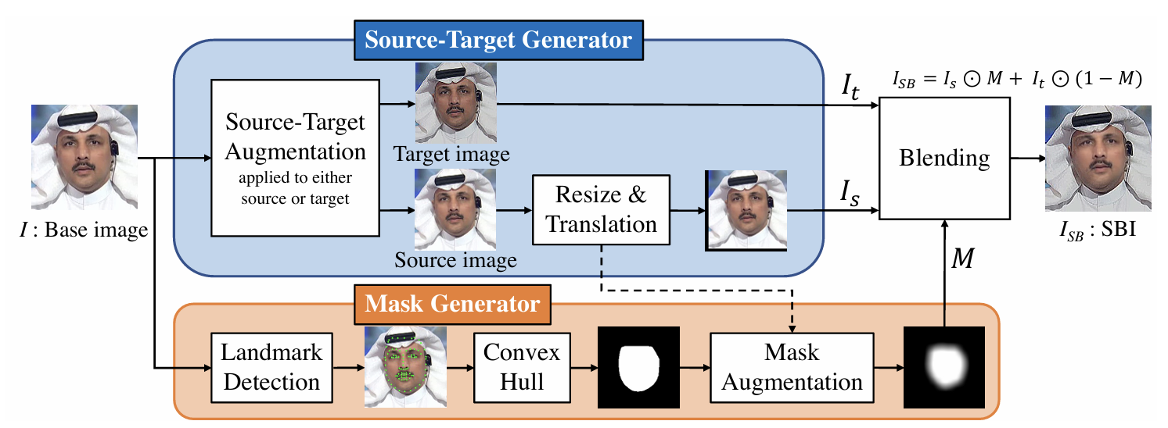
Figure 4: The Self-Blended Images (SBI) generation pipeline, creating synthetic training samples from a single source image. Source: Shiohara & Yamasaki, "Detecting Deepfakes with Self-Blended Images" (2022).

Overview of generating an SBI. A base image I is input into the source-target generator (STG) and mask generator (MG). STG generates pseudo source and target images from the base image using some image transformations, whereas MG generates a blending mask from the facial landmarks and deforms it to increase the diversity of the mask. Finally, the source and target images are blended with the mask.

Unlike previous methods that require external datasets, SBI utilizes a single clean base image $(I)$ to simulate common Deepfake artifacts, such as blending boundaries and statistical inconsistencies.

The generation process consists of three core stages:
- Source-Target Generator (STG): The STG produces simulated source $(I_{S})$ and target $(I_{T})$ images by duplicating the base image $I$. To introduce statistical discrepancies, random color transformations (e.g., RGB shift, hue, saturation, and contrast) and frequency transformations (e.g., down-sampling or sharpening) are applied. To replicate landmark misalignment and blending boundaries, the source image $(I_{S})$ undergoes random resizing and translation.
- Mask Generator (MG): The MG identifies facial landmarks to define a facial region (convex hull) and generates a grayscale blending mask $(M)$. This mask is further diversified using elastic deformations and Gaussian smoothing. The blending ratio is controlled by a variable $r∈\{0.25, 0.5, 0.75, 1\}$, which is applied to the mask.
- Blending: The final SBI $(I_{SB})$ is synthesized by merging the transformed source and target images through the processed mask. Notably, this method maintains a constant runtime per sample, as it eliminates the need for the nearest-neighbor landmark searches required by earlier synthetic methods.

The blending operation, which combines the simulated source and target images, is defined as:
$I_{SB}=I_{S}⊙M+I_{T}⊙(1-M)$.

where $I_{S}$ and $I_{T}$ are the augmented source and target images respectively, $M$ is the grayscale blending mask, and $⊙$ denotes element-wise multiplication.

The generated SBIs are used to train a binary classifier $(F)$ using the Binary Cross-Entropy (BCE) Loss. During training, the target images $(I_{T})$ are labeled as "Real" to force the model to focus exclusively on detecting the artifacts introduced during the blending process. The loss function is formulated as:

$L=-\frac{1}{N}\sum_{i=0}^{N-1}{\left\{t_{i}logF\left(x_{i}\right)+\left(1-t_{i}\right)log⁡(1-F\left(x_{i}\right))\right\}}$.
where $x_{i}$ represents the input image, $t_{i}$ is the binary label ("Fake" or "Real"), and $F_{(x)}$ denotes the predicted probability of the input being "Fake".

While SBI achieves SOTA on known benchmarks, recent research suggests it struggles with out-of-distribution data because it is still training a specific classifier on specific synthetic spatial artifacts, lacking semantic understanding of the scene.

- SBI Algorithm Operational Flow
The operational logic of the SBI generation is formalized as a structured sequence designed to automate the transition from a single real image to a complex synthetic sample. As illustrated in Algorithm 1, this workflow translates the theoretical components into a computational pipeline:

Pseudo code for SBI generation:

input: base image I of size (H, W,3), facial landmarks L of size (81,2)
output: self-blended image Isb of size (H, W, 3)

- Def T(I) $→$ source target augmentation
- I $←$ ColorTransform(I)
- I$←$ FrequencyTransform(I)
- return I
- if Uniform (min=0, max =1) < 0.5:
- Is,It $←$T(I), I
- else:
- Is,It $←$ I, T(I)
- Is, p $←$RandomResizeTranslate(Is) $→$ p: Parameter
- L$←$ LandmarkTransform(L)
- M $←$ConvexHull(L)
- M$←$ParameterizedResizeTranslate(M, p)
- M$←$ MaskDeform(M)
- r $←$ Uniform ({0.25,0.5,0.75,1,1,1})
- M $←$rM
- Isb$←$ Is $⊙$ M + It $⊙$ (1-M)

- Step 1: Initialization. The algorithm ingests a base image $(I)$ and its associated facial landmarks $(L)$, which serve as the geometric anchor for all subsequent transformations.
- Step 2: Stochastic Stream Selection. One of the two duplicated streams is stochastically selected for augmentation. This creates the primary discrepancy between the source and target, simulating the statistical "noise" typical of GAN-based synthesis.
- Step 3: Geometric Perturbation. A deliberate spatial mismatch is introduced by applying rigid transformations to the source face. ensures that the integration boundaries remain structurally inconsistent, providing a challenging signal for the detector.
- Step 4: Dynamic Mask warping. The mask $(M)$, computed from the convex hull of $L$, is not merely applied; it is dynamically warped and smoothed. This mimics the irregular blending artifacts found in real-world deepfakes.
- Step 5: Composite Synthesis. The pipeline concludes with the final pixel-wise integration through the transformed mask, yielding the Self-Blended Image $(I_{SB})$ ready for binary classification training.

- InstructBLIP
While methods like SBI focus on synthesizing spatial artifacts to train binary classifiers, InstructBLIP represents a paradigm shift towards general-purpose vision-language modeling. InstructBLIP is a vision-language instruction tuning framework designed to enable models to solve a wide range of tasks through a unified natural language interface.

Unlike traditional detectors that require task-specific heads, InstructBLIP initializes training with a pre-trained BLIP-2 model, consisting of an Image Encoder, a Large Language Model (LLM), and a Query Transformer (Q-Former) to bridge the two. Its core innovation lies in its Instruction-Aware Visual Feature Extraction, which allows the model to extract visual features tailored specifically to the given instruction.

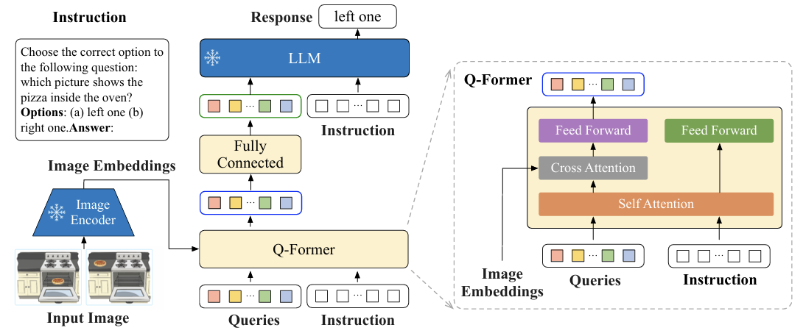
Figure 5: The InstructBLIP architecture illustrating the instruction-aware Q-Former mechanism. Source: Dai et al., "InstructBLIP: Towards General-purpose Vision-Language Models with Instruction Tuning" (2023).
The architecture comprises three primary components:
- Frozen Image Encoder: The visual input is processed by a Vision Transformer (specifically ViT-g/14 ). This component remains frozen during instruction tuning, preserving the robust visual representations learned during massive pre-training.
- Instruction-Aware Q-Former: The Query Transformer acts as a bottleneck module that bridges the modality gap. Unlike the original BLIP-2 where the Q-Former is instruction-agnostic, InstructBLIP feeds the textual instruction into the Q-Former along with the query embeddings. This enables the extraction of task-relevant image features.
- Frozen LLM: The extracted visual features serve as soft prompt inputs to a frozen LLM (e.g., FlanT5 or Vicuna), which generates the final textual response.

The critical mechanism distinguishing InstructBLIP is how it handles the interaction between visual queries and user's prompt. In standard zero-shot methods, static visual representations are fed to the LLM regardless of the task. In contrast, InstructBLIP adapts the visual features based on the instruction.

The Q-Former utilizes $K$ learnable query embeddings (experimentally set to $K=32$ ). These queries interact with the instruction text tokens through the Self-Attention layers of the Q-Former. Simultaneously, the queries interact with the frozen image encoder's output through Cross-Attention layers.
This mechanism encourages the extraction of visual features that are specifically conducive to the task described in the instruction. As a result, the LLM receives visual information that is highly relevant to instruction below.

During instruction tuning, the Image Encoder and the LLM remain frozen. Only the parameters of the Q-Former $(θ_{Q})$ are fine-tuned. The model is trained using the standard Language Modeling (LM) loss to directly generate the response given the instruction.

The optimization objective can be formalized as minimizing the negative log-likelihood of the target text $Y$ given the image $I$ and the instruction $T$:

$L=-\sum_{t=1}^{\left|Y\right|}{log⁡P_{θQ}\left(y_{t} | y_{<t} , I , T\right)}$,
Where $y_{<t}$ represents the predicted token at step $t$.

- Zero-Shot Learning (ZSL)

Zero-shot learning (ZSL) is a machine learning scenario where an AI model is trained to recognize and categorize objects or concepts without having seen any examples of those specific categories beforehand. This approach addresses a major limitation of standard supervised learning, which requires large amounts of labeled data for every single class the model needs to learn. In many real-world cases, such as identifying rare diseases or newly discovered species, annotating data is too costly or simply impossible.

In the absence of labeled examples for new classes, ZSL relies on "auxiliary information". This information can take the form of textual descriptions, semantic attributes, or vector embeddings.
To understand this concept, consider how a human learns: a person can recognize a bird they have never seen before by understanding the concept of a bird (e.g., it has wings, feathers, and a beak) rather than memorizing every specific bird image. Similarly, Large Language Models (LLMs) are naturally suited for ZSL because they possess a fundamental understanding of the words and concepts used to label data.

A more realistic and challenging variation is Generalized Zero-Shot Learning (GZSL). In this setting, the model must classify data that could belong to either the new, unseen classes or the classes it has already learned during training. The main challenge in GZSL is that classifiers tend to be biased toward the familiar classes they saw during training, requiring specific techniques to correct this bias.

There are three primary approaches to implementing ZSL:

- Attribute-Based Methods: These methods train the model to recognize specific features (like "stripes," "yellow," or "flying") rather than the object as a whole. The model can then identify a new object (e.g., a bee) by combining these learned attributes (e.g., "yellow, striped, flying insect").

- Embedding-Based Methods: This approach represents both the data samples and the class labels as vectors (semantic embeddings) in a shared mathematical space. Classification is performed by measuring the distance or similarity between the input data's embedding and the class embedding. To achieve this, models often use Transfer Learning, repurposing pre-trained networks like BERT (for text) or ResNet (for images) to generate these embeddings.

- Generative-Based Methods: These methods use auxiliary information to synthesize artificial data for the unseen classes. By generating these synthetic samples, the problem is effectively converted back into a standard supervised learning task. Common architecture used for this includes Variational Autoencoders (VAEs) and Generative Adversarial Networks (GANs).

- Few-Shot Learning (FSL)

Few-Shot Learning (FSL) is a machine learning framework where an AI model learns to make accurate predictions after training on a very small number of labeled examples. This approach mimics human learning, where people can learn new concepts from just a handful of examples, unlike traditional supervised learning which requires thousands of labeled data points. FSL is crucial in scenarios where labeled data is scarce, expensive to obtain, or requires domain-specific expertise, such as in medical imaging or identifying rare species. FSL typically employs two main strategies: Transfer Learning and Meta-Learning.

- Transfer Learning: This involves adapting a pre-trained model (trained on a large dataset) to a new, similar task using only a few labeled samples. For example, a model trained to classify bird species can be fine-tuned to recognize a new, unseen bird species with just a few images because it has already learned relevant features like beak shape and wing patterns. To prevent "catastrophic forgetting" of the original knowledge, researchers often freeze the internal layers of the model and only retrain the final classification layers.
- Meta-Learning: Also known as "learning to learn," this approach trains models on a variety of tasks so they can quickly adapt to new tasks with minimal data. In this framework, the model learns the process of learning itself, optimizing its initial parameters so that it can generalize well to new problems after just a few update steps.

N-way-K-shot Classification FSL tasks are standardly evaluated using an N-way-K-shot framework.
- N-way: Refers to the number of classes the model needs to classify.
- K-shot: Refers to the number of labeled examples provided for each class (the "shots"). For instance, a 3-way-2-shot task involves classifying images into 3 distinct categories, given only 2 labeled examples for each category. The training process involves Episodes, where each episode contains a Support Set (the few labeled examples) and a Query Set (new examples to classify based on the support set).

Several specialized algorithms have been developed for FSL:
- Metric-Based Methods: These algorithms, like Prototypical Networks, map data samples into a vector space and classify new queries based on their distance (e.g., Euclidean distance) to the "prototype" (average representation) of each class. Siamese Networks and Matching Networks also fall into this category, using similarity scores to classify new inputs.
- Optimization-Based Methods: Algorithms like Model Agnostic Meta-Learning (MAML) focus on finding an optimal initialization of model parameters. This "meta-initialization" allows the model to reach high performance on a new task after only a few steps of gradient descent, effectively acting as a highly efficient fine-tuning process.

- Methodology

In this chapter, we will bridge the gap between the theoretical background and the actual implementation. Our goal is to demonstrate how we can take a powerful generative model like InstructBLIP, that its original goal it to describe images, and adapt it to function as a precise deepfake detector. The main challenge that we will present can be divided to two parts, the conceptual and following that the technical; the transition from a model that generates free text to a system that produces a definitive probabilistic score.

  - System overview

The objective of the proposed system is to adapt a generative Vision-Language Model, originally designed for tasks such as image captioning, into a precise binary classifier for Deepfake detection. Our approach is based on the hypothesis that models trained on Immense amount of information – visual and textual, and they have deep semantic understanding of the world, that allows them to identify anomalies and fakes better than classic classifiers, which tend to focus on pixel level artifacts.
The architecture that was chosen for the project is InstructBLIP. The choice was made because of the model’s unique capability for Instruction-Aware Visual Feature Extraction.
The model consists of 3 main components:
- Image encoder: this component is based on vision transformer (ViT-g/14) and is responsible for processing the visual input. In our project, this component remains “frozen” throughout the whole process to preserve the robust visual representation learned during pre-training.
- LLM: Large Language model serves to generate the textual response. This component is also frozen.

- Q- Former: this component is used as the bridge between the visual model and the language model. Unlike previous models (such as BLIP2), in instructBlip, the Q-Former receives both the image and the textual instruction as an input (and is not frozen).

The information flow in the systems proceeds as follows:
- The systems receive an image (I) and a natural language question (Q), such as ‘is this photo real?’

- The Q-Former processes the image according to the specific question, extracting visual features that are most relevant to the deepfake detection task.

- These features are passed to the LLM, which generates the final response.
This structure allows us to leverage the model’s prior knowledge (Zero-Shot) while, in the case of Fine-tuning, training only the relatively lightweight Q-Former component, thereby saving computational resources and preventing catastrophic forgetting.

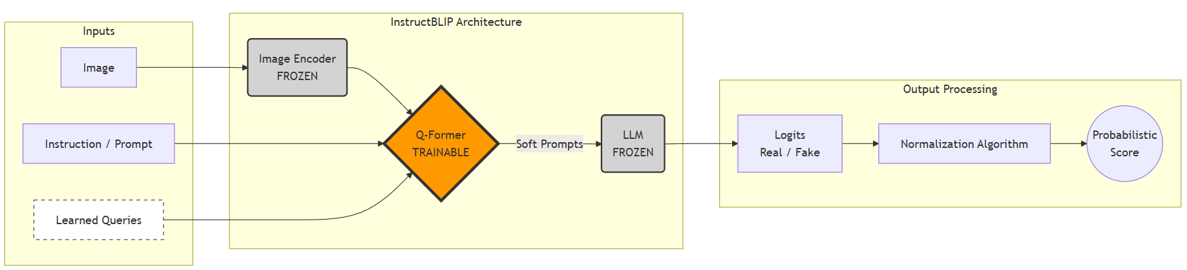
Figure 6: probabilistic inference process using instructBLIP.
The flowchart illustrates the adaptation of the model from text generation to binary deepfake classification. The system receives an image and a close ended query (“is this photo real?”), but instead of decoding an actual textual response, the algorithm directly extracts from the output layer the logits for the tokens “Yes” or “No”. These values are normalized to calculate the probability P(Real | Image), enabling accurate classification based on the model’s pre-trained semantic knowledge (Zero-Shot) without the need for an external classifier.

- Probabilistic Inference Algorithm
The main challenge with using Visual Language Models (VLMs) for this tasks it their natural output is free text (such as ‘yes’ \‘no’). For biometric purposes, binary output is not enough. A specific confidence score is required to calculate metrics like AUC and EER, and to set a precise threshold.
To solve this, an algorithm was implemented to turn the generative output into a probabilistic classifier. Instead of relying on the generated text, this method uses tokens probabilities directly from the model.
The algorithm defines the tokens ‘Yes’ and ‘No’ to represent the classes ‘Real’ and ‘Fake’ respectively. For every image, the model calculates the probability of those tokens. Afterwards, normalization is performed to extract the score for the fake class, as defined in the in the following equation (from the base paper):
$P\left(Fake\right)= \frac{P_{no}}{P_{yes}+P_{no}}$.
The normalization method was selected because using a Softmax function over the entire vocabulary (which is huge) may be inaccurate. Normalizing over the relevant subset ('Yes', 'No') ensures that the sum of probabilities equals 1 and reflects the relative confidence strictly between the two options.

- Training and Fine-tuning Strategy
The research methodology in this project evaluates the system in two configurations: Zero-Shot inference and Few-shot fine tuning. For the training phase, a Parameter-Efficient Fine-Tuning strategy was selected, specifically adapted for such models.
In the InstructBLIP architecture, the Fine-tuning process does not update all model parameters. Instead, the Image Encoder and the Large Language Model (LLM) components remain "frozen" during training. Weight updates are performed exclusively on the Q-Former component.
This approach for two primary reasons:
- Prevention of catastrophic forgetting: Freezing the LLM and the Encoder allows the system to retain the knowledge gained during pre-training on million of images. This prevents the model from losing its general capabilities while adapting to the specific task.
- Computational efficiency: Training only the Q-Former requires significantly less memory and processing power compared to full fine-tuning of a large language model.

The learning process involves minimizing standard language modeling loss function. This function measures the probability of predicting the correct tokens based on the image and the instruction.
For the DFCD-P dataset, a 1:10 split between the training and testing was used. according to the base paper, training for a single enough to achieve high performance and domain adadption.

- System Inputs
The system processes two kinds of inputs: visual and textual. Data selection follows the protocol described in studies by Chen et al. (SimSwap) and Pirogov (the base paper).

    - Visual datasets

for training and testing, two main datasets are used:

  - CelebA-HQ Deepfake (For Zero-Shot Experiments): This dataset is based on the original CelebA-HQ images. The deepfakes were created using the SimSwap model, which was chosen because it generates high-quality face swaps while keeping original attributes. This allows the system to be evaluated against advanced GAN-based forgeries. The dataset contains 60,000 images (30k real, 30k fake) and is used to evaluate Zero-Shot capabilities, as described in the Base Paper.

  - DFDC-P (Deepfake Detection Challenge Preview): This dataset is used for detection challenges in difficult, real-world conditions. Like the methodology in the base paper, this data set is used for the fine-tuning phase. Frames sampled from the videos (32 per video) are used to train the Q-Former to recognize specific artifacts in this domain.

    - Textual datasets

According to the Base Paper (Pirogov, 2025), model performance depends heavily on the chosen prompt. It was found that simple binary instruction gives the most accurate results for the model InstructBLIP.
Therefore, the selected prompt is: “is this photo real?”
This choice allows the model to focus the token distribution on the answers "Yes" and "No", which are used to calculate the probabilistic score.

    - Model Evaluation and Results validation

In the implementation phase (Phase B), the system’s performance will be evaluated on the DFDC-P test set, utilizing a supervised validation protocol where model predictions are compared against known Ground Truth labels (0 for "Real", 1 for "Fake"). Unlike standard image captioning, the validation process will leverage Probabilistic Inference: for every input image x, the VLM will be prompted to classify the image. Instead of relying on the textual output, we will extract the logits associated with the target tokens (e.g., "Real"\"Fake" or "Yes"\"No"). by applying the normalization technique proposed in the base paper) to these logits we will derive a continuous probability score P (Fake | x). This score allows precise thresholding and anomaly detection analysis.
The primary metrics for evaluation will be AUC (Area Under Curve), which assesses the model's separation capability independent of a specific decision threshold, and Accuracy (ACC) at a fixed threshold. The evaluation strategy aims to demonstrate the superiority of the proposed Fine-Tuned VLM over both the baseline Zero-Shot VLM and traditional detection methods (such as SBI). Special emphasis will be placed on Generalization, ensuring the model detects Deepfakes that were not seen during the training phase.

Table 1: Planned Evaluation Metrics & Performance Comparison
Method / Architecture | Setup / Training Strategy | Metric: AUC (%) | Metric: Accuracy (%)
Traditional (e.g., SBI) | Supervised / Self-Blended | Baseline to beat | Baseline to beat
InstructBLIP (Base Paper) | Zero-Shot (No training) | Reference Value | Reference Value
Ours: InstructBLIP | Few-Shot / Fine-Tuned | Target: > Reference | Target: > Reference
Ours: InstructBLIP | Cross-Dataset (Generalization) | To be measured | To be measured
    - Test Plan
Test Case Name | Description
SBI Module (Data Generation) | Tests for the Self-Blended Images algorithm
SBILoadImage | Test that a standard image loads successfully from the disk and converts to RGB format.
SBILandmarkDetection | Test that the system successfully detects face landmarks (points on the face) on a clear photo.
SBIMaskGeneration | Test that the system creates a valid blending mask (not empty or all black) after detecting the face.
SBIBoundaryCheck | Test that the final blended image keeps the correct size (e.g., 224x224) and does not have errors at the edges.
InstructBLIP Module (Detection) | Tests for the VLM Model
InstructBLIPModelLoad | Test that the InstructBLIP model and processor load into memory without crashing.
InstructBLIPImagePrep | Test that the processor correctly converts an image into the tensor format required by the model.
InstructBLIPGetText | Test that the model returns a text answer (like "Yes" or "No") when asked "Is this photo real?".
InstructBLIPMathCheck | Test that the normalization formula (Fake Score divided by Total Score) correctly returns a number between 0 and 1 (Real + Fake =1).
System Integration | End To End Tests
DetectRealSanity | Run the system on a known real image and check that the "Fake Probability" is low (e.g., below 0.5)
DetectFakeSanity | Run the system on an SBI-generated image and check that the "Fake Probability" is high
ThresholdCheck | Test that the system correctly decides "Fake" or "Real" based on the specific threshold number you set (e.g., 0.5).

- References List

- InstructBLIP: Dai, W., Li, J., Li, D., Tiong, A. M. H., Zhao, J., Wang, W., ... & Hoi, S. (2023). InstructBLIP: Towards General-purpose Vision-Language Models with Instruction Tuning. NeurIPS.
- SimSwap: Chen, R., Chen, X., Ni, B., & Ge, Y. (2020). SimSwap: An Efficient Framework for High Fidelity Face Swapping. ACM International Conference on Multimedia.
- SBI: Shiohara, K., & Yamasaki, T. (2022). Detecting Deepfakes with Self-Blended Images. CVPR.
- Base Paper: Pirogov, V. (2025). Visual Language Models as Zero-Shot Deepfake Detectors. arXiv preprint.
- Few-Shot: Parnami, A., & Lee, M. (2022). Learning from Few Examples: A Summary of Approaches to Few-Shot Learning.
- Zero-Shot: Pourpanah, F., Abdar, M., Luo, Y., Zhou, X., Wang, R., Lim, C. P., Wang, X.-Z., & Wu, Q. M. J. (2022). A Review of Generalized Zero-Shot Learning Methods.

